Name _____________________________
Address____________________________
Phone_____________________________
Email______________________________
First Names & Initials:
1.___________-____ 2.__________ - ____
3.__________ -____ 4.__________ - ____
5.__________ -____ 6.__________ - ____

_____I/we commit to weekly worship. I/we will make every effort to be present at weekly Mass.
(Place X under continue or interested as appropriate)
HOSPITALITY MINISTRIES

Name initial continue interested
________ Art & Environment ____ ____
________Childcare Sunday Mass ____ ____
________Events Committees
(Lau, Fall Festival, etc) ____ ____
________Scouting Programs ____ ____
________Sports/Athletics ____ ____
________Usher, Greeter ____ ____
________Web Site Design & update ____ ____
________Welcome Committee ____ ____

PRAYER MINISTRIES

Name initial continue interested
________ Altar servers ____ ____
________Children's Liturgy ____ ____
________Extraordinary Minister ____ ____
________Lector ____ ____
________Music Ministry & Cantor ____ ____

Name initial continue interested
________Prayer Opportunities
(Rosary & Adoration) ____ ____
________Sacristan ____ ____
________Serra Club ____ ____
________Worship Council ____ ____
________Militia Immaculata ____ ____

FORMATION MINISTIES

Name initial continue interested
_______Book Club ____ ____
_______Catechesis of the Good
Shepherd ____ ____
_______Evangelization and ____ ____
Parish Life Council ____ ____ _______Marriage Prep. Couples ____ ____
_______Neocatechumenal Way ____ ____
_______Parish Development C. ____ ____
_______Sacramental preparation ____ ____
_______School of Religion ____ ____
_______School Advisory Council ____ ____
_______School Development C. ____ ____
_______Scripture studies ____ ____
_______That Man is You ____ ____ _______Youth Group ____ ____
_______Stewardship Council ____ ____
_______Young Adult & Family ____ ____

SERVICE MINISTRIES

Name initial continue interested

________Annual Blood Drive ____ ____
________Birthday Cakes
for nursing home ____ ____
________Building & Grounds
Maintenance ____ ____
________English as Second
Language ____ ____

Name initial continue interested
________Preschool Volunteers ____ ____
________Funeral dinners ____ ____ ________Gardening angels ____ ____
________Immigration/Refugee
Services ____ ____
________Knights of Columbus ____ ____
________K of C Ladies Aux. ____ ____
________Meat Loaves for
One City Cafe ____ ____
________Money Counters ____ ____
________Office Volunteer ____ ____
________Prison Ministry ____ ____
________Donate to Food Pantry ____ ____
________Respect Life Committee ____ ____
________School Volunteers ____ ____
________Sewing (Baptismal, alter
linen & Vestments) ____ ____
________Sister Parish, Ita Mura ____ ____
________Social Services Council ____ ____
________St James One City Cafe ____ ____
________Hickman Mills Comm. All. ____ ____

I/we are not able to commit to a ministry at this time but will take time to ….

_____Attend at least one session on faith formation
_____Say a daily prayer for the success of St. Regis
and those who carry on its ministries.
_____Set aside daily time for our family prayer.

Other areas of interest/talents/skills:
______________________________________________________________________________________

WHAT ARE THE 4 PILLARS OF STEWARDSHIP?
All of our ministries fit in the categories of the following 4 Pillars of Stewardship:
HOSPITALITY: We strive to extend a warm, hospitable and loving welcome to all who join us in worship, service, study, social or in times of personal need.
PRAYER: We grow as disciples who are committed to prayer—individual and communal prayer, public and private prayer. Through prayer we are invited to draw closer to Jesus and to imitate Him in our daily lives. While Eucharist is central to our spiritual life, other prayer opportunities are made available.
FORMATION: We strive to educate, form and sustain the stewardship way of life for all ages through faith formation opportunities in the parish, school and ECC. We are open to the continuous conversion to a life of stewardship – to sharing what one has with a loving, generous and grateful heart.
SERVICE: We strive to be servant ministers to the need of our parish members, the wider community and Church. We strive to serve compassionately those who are hurting or in need, lost or alone, or suffering in any way. Through service we give thanks to God for all the gifts we have received.

Hospitality
Christian Kindness: "When I was a stranger, you welcomed me." (Matt. 25:35)

Prayer
A Heart to Heart with God: "Prayer is as necessary to our souls as food is to our bodies." (Characteristics of a Christian Steward)

Formation
Continuous Conversion: "Being a disciple is not just something else to do, alongside many other things suitable for Christians. It is a total way of life and requires continuing conversion." (USCCB's Stewardship a Disciple's Response - Pastoral Letter on Stewardship)

Service
Love in Action: "...Amen I say to you, whatever you did for the least of my brothers, you did for me." (Matt. 25:40)

ST. REGIS PARISH & ACADEMY 2021TIME & TALENT COMMITMENT FORMS
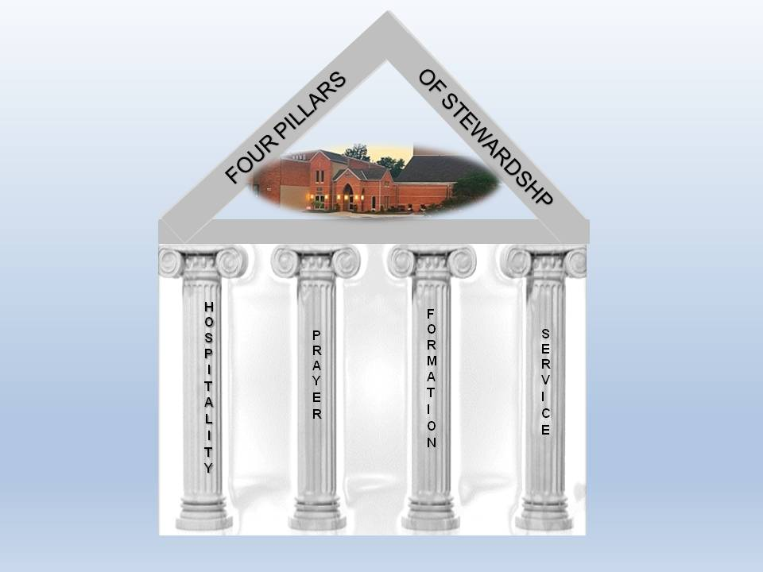
WHERE DO YOU FIT IN THE 4 PILLARS OF STEWARDSHIP?

As you reflect on our theme this year – “Serve One Another,” consider where your skills and talents can best be used to thank God for all that he has done for you. You may already be involved in one or more of our 50+ ministries, Thank You. If you are not involved in any ministries, prayerfully consider getting involved. Fill out and turn in this Time & Talent brochure along with your Treasure (Financial) Commitment card by the weekend of November 21-22.

