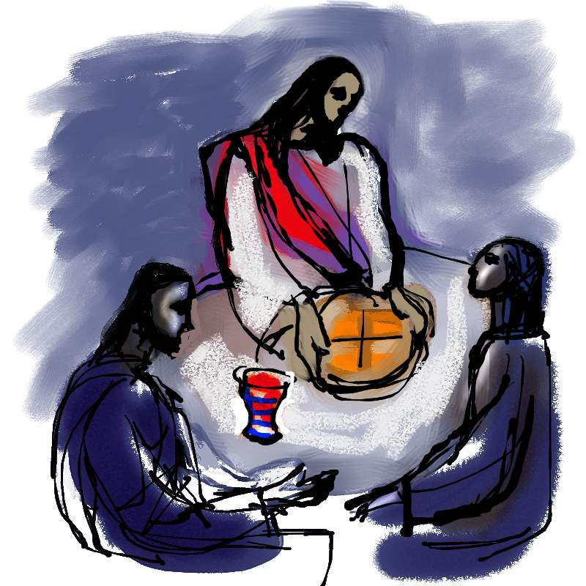
3rd Sunday of Easter
April 17th vigil mass, Sat @ 3:00 p.m.
April 18th Sunday morning @ 8:30 a.m.
April 18th First Communion @ 1:pm
Year of Our Lord 2021

ST. JOHN FRANCIS REGIS
Catholic Church
8941 James A Reed Rd
Kansas City, MO 64138

PROCESSIONAL SONG: (or see pg 2)

PROCESSIONAL SONG:
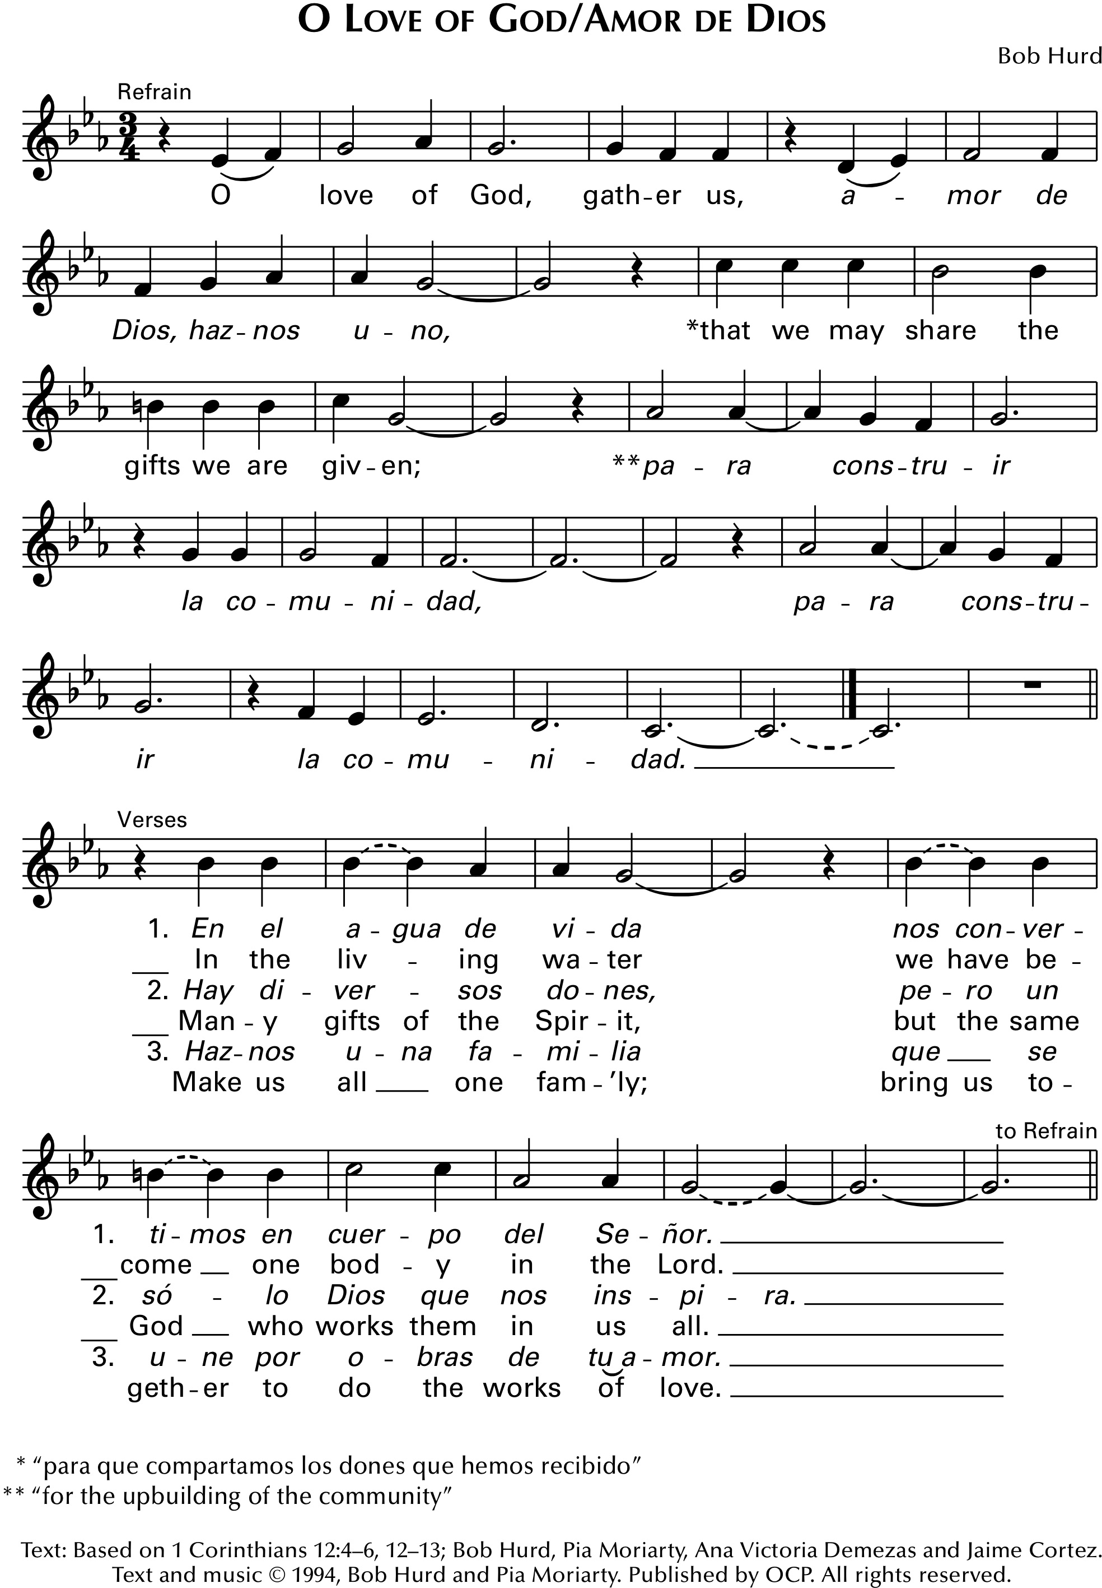

SIGN OF THE CROSS & GREETING

PENITENTIAL RITE

OR, BLESSING OF WATER AND SPRINKLING (optional):

God, you have moved upon the waters,
you have sung in the rush of wind and flame;
and in your love, you have called us sons and daughters,
make us people of the water and your name.
1. Come fill our waiting hearts with the spirit of Jesus,
let us shine with your light and peace.
God, you have moved...

2. Give us a thirst for love, give us a hunger for justice,
make us one with the mind of Christ.
God, you have moved...
3. You are the breath of life, you are the hope of the hopeless,
come and fill us with light and peace.
God, you have moved...
4. Come, open ev'ry heart, come now and wake us to wonder,
make us vessels of light and peace.
God, you have moved…

Text: Marty Haugen, b.1950, © 1987, GIA Publications, Inc.
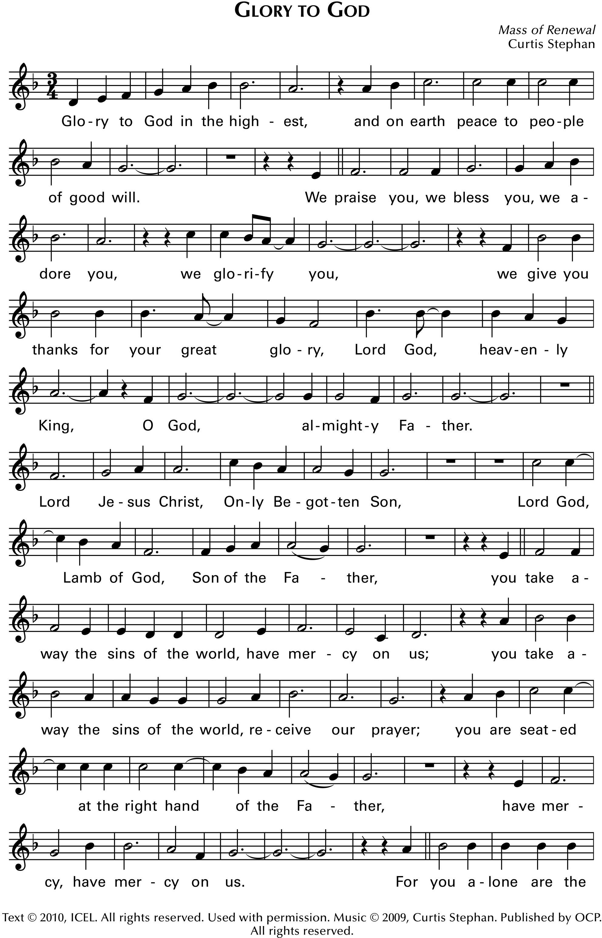
COLLECT (OPENING PRAYER)

The Liturgy of the Word
All are seated for the readings from the Word of God.
FIRST READING / PRIMERA LECTURA ACTS 3:13-15, 17-19
Peter said: “The author of life you put to death, but God raised him from the dead”

RESPONSORIAL PSALM: Psalm 4
LORD, let your face shine upon us; shine upon us, shine upon us.
(Or) LORD, let your face shine upon us. Lord, let it shine.

EPISTLE 1 JOHN 2:1-5a
Jesus Christ is expiation not for our sins only, but for those of the whole world.

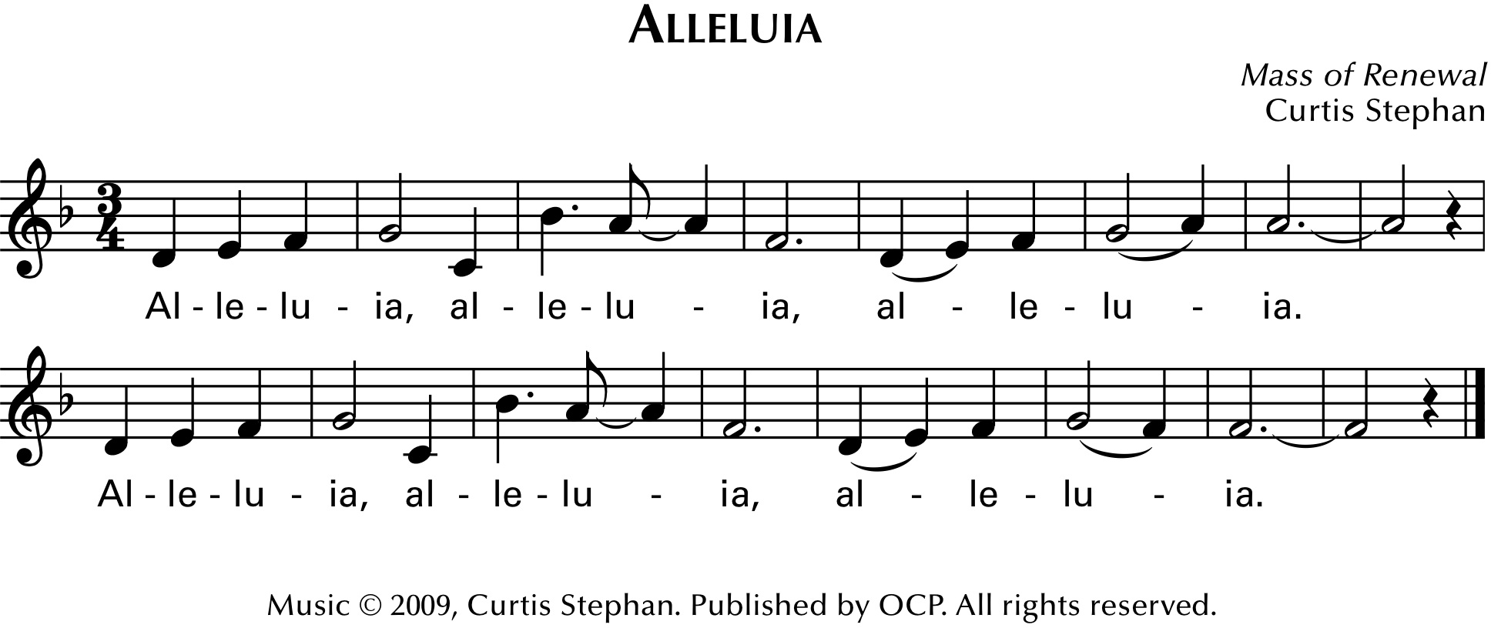

GOSPEL / EVANGELIO LUKE 24-35-48
Thus it was written that the Christ would suffer and rise from the dead on the third day.
HOMILY
NICENE CREED
GENERAL INTERCESSIONS

PREPARATION OF THE GIFTS: (Instrumental)
DIALOG AND PREFACE
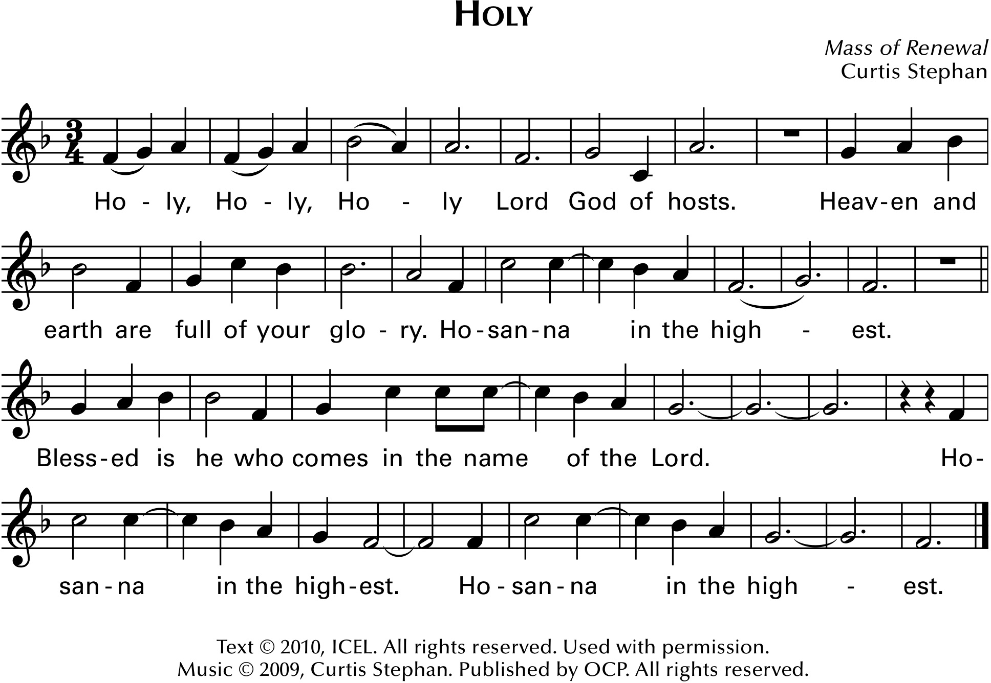

THE EUCHARISTIC PRAYER

MYSTERY OF FAITH: 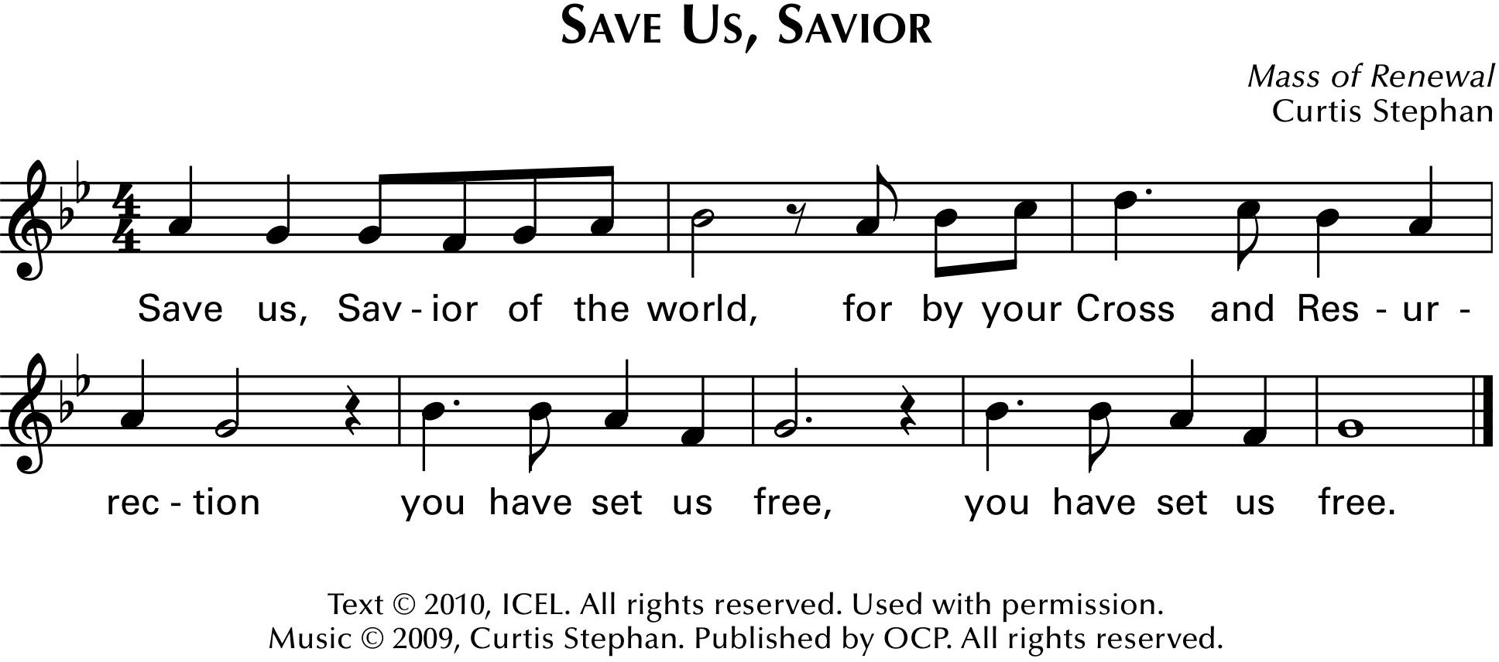
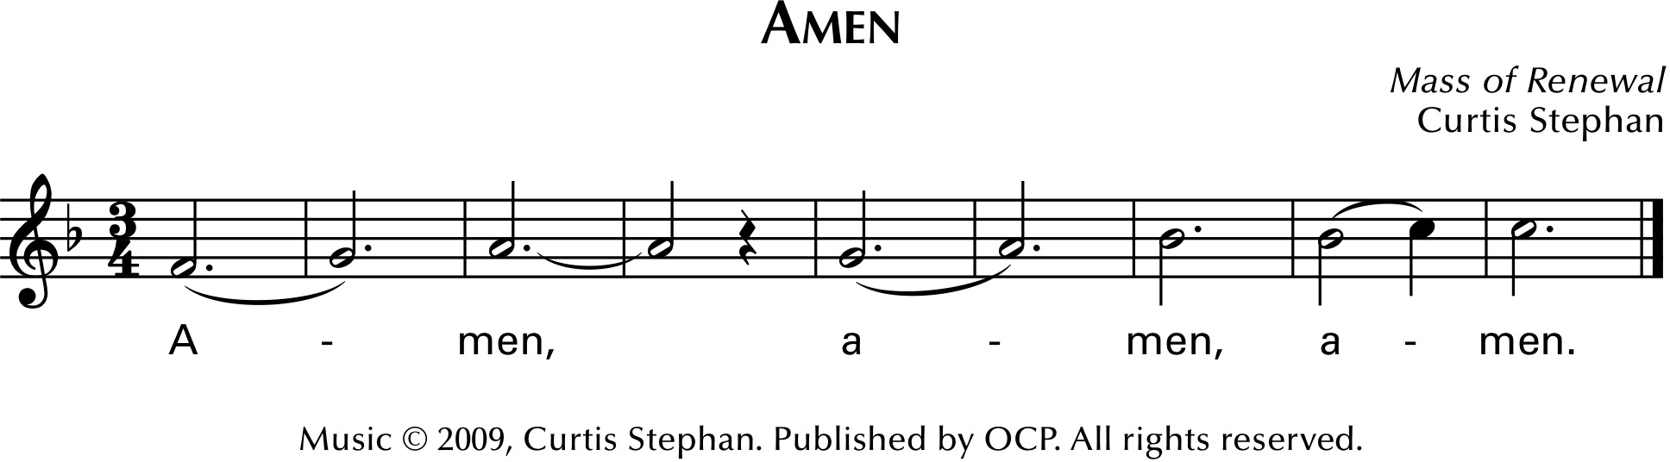

OUR FATHER:

SIGN OF PEACE
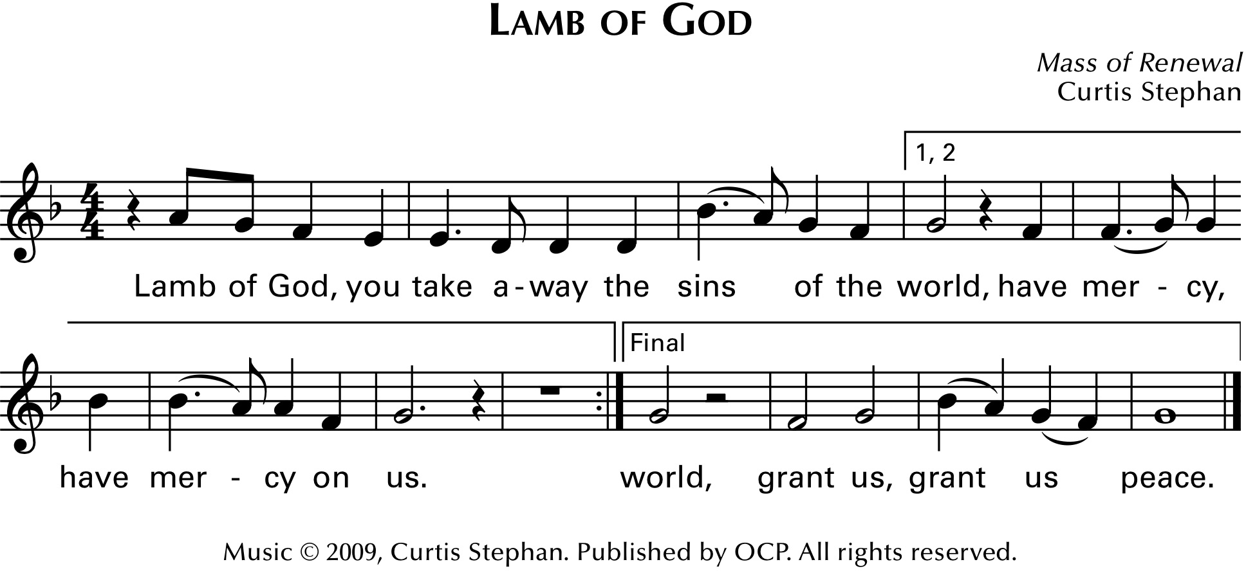

COMMUNION HYMN: In the Breaking of the Bread

In the breaking of the bread we have known him; we have been fed.
Jesus the stranger, Jesus the Lord, be our companion; be our hope.

1. Bread for the journey, strength for our years,
manna of ages, of struggle and tears.
Cup of salvation, fruit of the land,
bless and receive now, the work of our hands. In the breaking…
2. Bread of the promise, people of hope,
wine of compassion, life for the world.
Gathered at table, joined as his body
sealed in the Spirit, sent by the Word. In the breaking…

Text: Based on Luke 24:18–35; Acts 2:42; Bob Hurd, b.1950, and Michael Downey, © 1984, 1987, Bob Hurd and Michael Downey. Spanish text by Stephen Dean and Kathleen Orozco, © 1989, OCP
Music © 1984, 1987, Bob Hurd. Published by OCP. All rights reserved.
COMMUNION HYMN: Pan de Vida
Pan de Vida, cuerpo del Señor, cup of blessing, blood of Christ the Lord.
At this table the last shall be first, poder es servir, porque Dios es amor.
1. We are the dwelling of God, fragile and wounded and weak.
We are the body of Christ, called to be the compassion of God.
Pan de Vida...
2. Ustedes me llaman 'Señor,' me inclino a lavarles los pies:
Hagan lo mismo, humildes, sirviéndose unos a otros.
Pan de Vida...
3. There is no Jew or Greek, there is no slave or free:
there is no woman or man; only heirs of the promise of God.
Pan de Vida...
Text: John 13:1-15, Galatians 3:28-29; Bob Hurd, b.1950, and Pia Moriarty, © 1988, Bob Hurd and Pia Moriarty.
Published by OCP Publications.
PRAYER AFTER COMMUNION:
BLESSING:

EASTER DISMISSAL: Thanks be to God! Alleluia! Alleluia!

RECESSIONAL SONG: Glory and Praise to Our God

Glory and praise to our God, who alone gives light to our days.
Many are the blessings he bears to those who trust in his ways.
1. We, the daughters and sons of him who built the valleys and plains,
Praise the wonders our God has done in ev'ry heart that sings.
Glory and praise...
2. In his wisdom he strengthens us, like gold that's tested in fire.
Though the power of sin prevails, our God is there to save.
Glory and praise...
3. Ev'ry moment of ev'ry day our God is waiting to save,
Always ready to seek the lost, to answer those who pray.
Glory and praise...
Text: Psalm 65, 66; Dan Schutte, b.1947, © 1976, Daniel L. Schutte and New Dawn Music. Published by OCP Publications.
MARIAN ANTIPHON: (one of these settings of the Regina Caeli may be sung after the recessional/sending song, throughout the Easter season)

Reprinted with permission under One License, License #A-724804. All Rights Reserved.

